Book Donation System Project
Introduction
Our Book Donation System Project called “Vidhya-Dhan” provides a platform for those who want to donate unused books and seek books that they can’t afford. A donor can donate the book and a seeker can seek the book that he/she need and is available. The system also provides some admin facility like block/unblock a donor or seeker, add book category and check the analytics etc.
Need of the System
Book Donation System Project fills the gap between the one who want to donate a book and one who want to seek a book that he/she can’t afford. There are many people who have many books that is no longer in use and many people who need some books but they can’t afford. This system provides a platform for such people and fills the gap between them.
Languages used
- Front-end – HTML, CSS, JavaScript
- Back-end – PHP and MYSQL
Hardware and Software requirement
- System with basic requirements
- XAMPP server (Local Server)
- Web browser (Chrome, Firefox etc.)
About the System
The system has mainly three modules as mentioned below:
- Admin
- Donor
- Seeker

Admin
This is the main module of the System that controls the overall System. The system provides some facilities to the admin that he can use to manage the system.
There are some functions that an admin can perform –

- View Donors - the admin can view the list of all the donors that is registered in the System. He can also block and unblock them. Once a donor is blocked by the admin he/she can’t put a request to donate a book.
- View Seekers – the admin can view the list of all the seekers that is registered in the System. He can also bock and unblock them. Once a seeker is blocked by the admin he/she can’t put a request to seek a book.
- Add book category – the admin can add a book category to the system. Book category is used to organize the system so that a donor and a seeker can easily search a book by the book category.
- Analytics – the admin can use the analytics section to check the analytics of the system. He can check top donor, top seeker and most demanded book category. It provides an overview of the system that can be useful to analyze the system.
- Logout – the admin can logout form the system once done with its work so that any unauthorized activities can be avoided.
Donor
This is another core module of the system. As the name suggest a donor is the person who want to donate any book. A donor has some facilities/functions that he can perform.
There are some functions that a donor can perform –
- Register – a donor has to register himself in the system if he/she wants to donate any book. Registration is a simple process he/she just needs to provide some basic details like name, email, password, mobile no and address etc.
- Login – a donor once registered in the system he/she can login to the system. Once he/she login to the system, he/she can access the donor’s dashboard to perform donor’s function.
- Donate book – donor can put a request to donate a book. He simply needs to provide some details like category of the book, name of the book and quantity of the book. Once the donor put a request to donate a book, the request is now visible to all the seekers so that they can find the book in search console.
- Seeker’s requests – this is the section where a donor can see all the seeker’s request that is made by the seekers for the books that the donor has put the request to donate. There might be more than one request for a book but the donor has the functionality to accept or reject the request.
- Logout – donor can logout from the system once he/she done with the work so that no other person can access his dashboard. It prevents from any unauthorized activities.
Seeker
- Register – a seeker has to register himself in the system in he/she wants to seek any book. Registration is a simple process he/she just needs to provide some basic details like name, email, password, mobile no and address etc.
- Login – a seeker once registered in the system he/she can login to the system. Once he/she login to the system, he can access the seeker’s dashboard to perform seeker’s functions.
- Seek request – seeker can put a request to seek any book that he/she wants to receive. There is a search console so that seeker can search the book that he/she wants to seek.
- My requests – this is the section where seeker can see all his/her requests to seek the books. He can check the status of all his requests made to seek a book. He can also view the details of the donor of the book if the donor has accepted his seek request.
- Logout – seeker can logout from the section once he/she done with his work so that no other person can access his dashboard. It prevents from any unauthorized activities.
Database Schemas

Admins
column | Type
id | int (11)
name | varchar (50)
email | varchar (50)
password | varchar (50)
mobile | bigint (20)

Donors
column | type
id | int (11)
name | varchar (25)
email | varchar (25)
password | varchar (25)
mobile | bigint (20)
address | varchar (150)
status | int (11)

Seekers
column | type
id | int (11)
name | varchar (50)
email | varchar (50)
password | varchar (50)
mobile | bigint (20)
address | varchar (150)
status | int (11)

Book_requests
column | type
id | int (11)
seeker_id | int (11)
donor_id | int (11)
book_cat | varchar (50)
book_name | varchar (50)
status | int (11)

donated_books
column | type
id | int (11)
donor_id | int (11)
cat_id | int (11)
book_name | varchar (100)
quantity | int (11)
date | timestamp
status | int (11)

Categories
column | type
id | int
name | varchar (50)
email | varchar (50)
password | varchar (30)
mobile | varchar (10)

DFD diagram

Admins
Block/unblock seekers
Donor’s detail
Block/unblock donors
Seeker’s detail
Donation request
Seek requests
Seekers
Donors
Donor’s details
Seeker’s requests

Seek request’s status

Database

ER diagram
email
name
id
email
name
password
id Some Screenshots of the project
Home Page
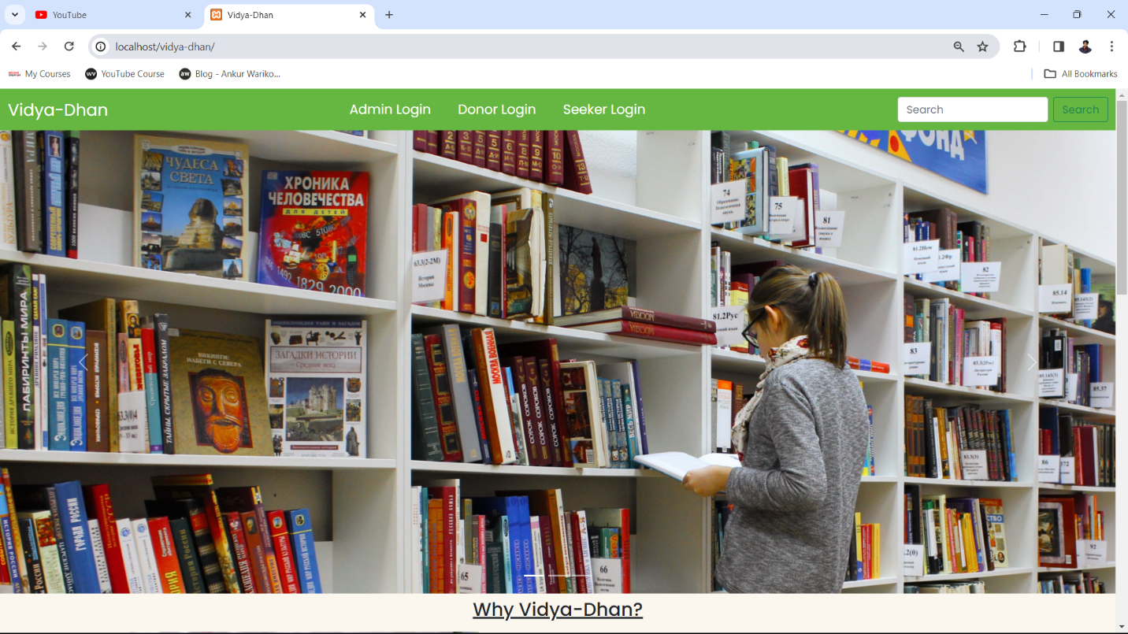

Admin Login Page
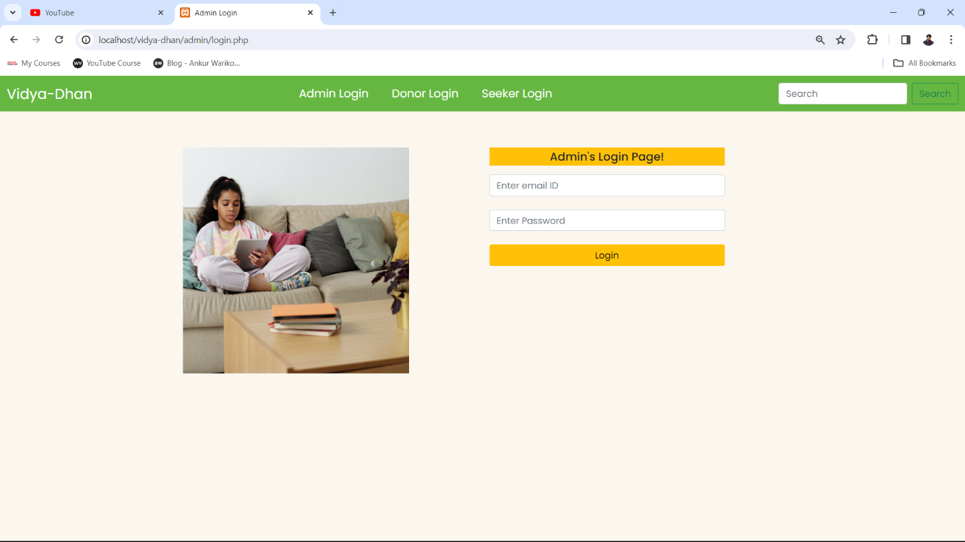
Donor register page
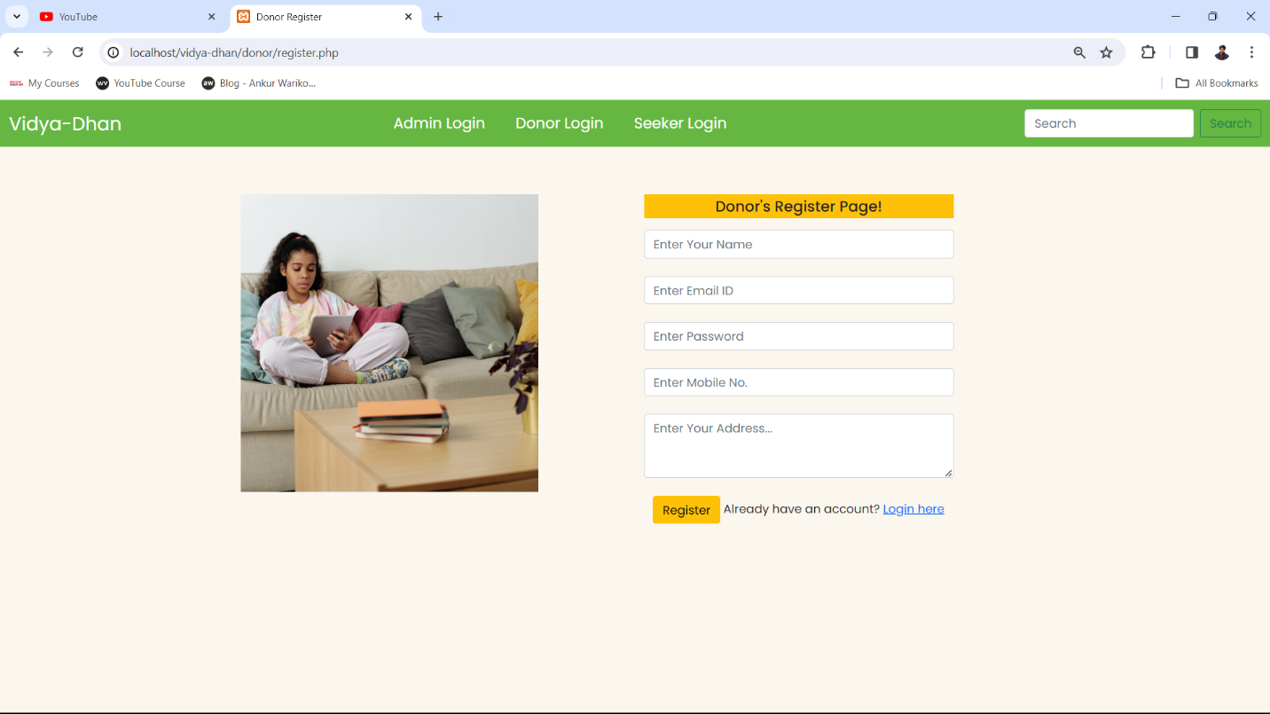

Admin Dashboard Page
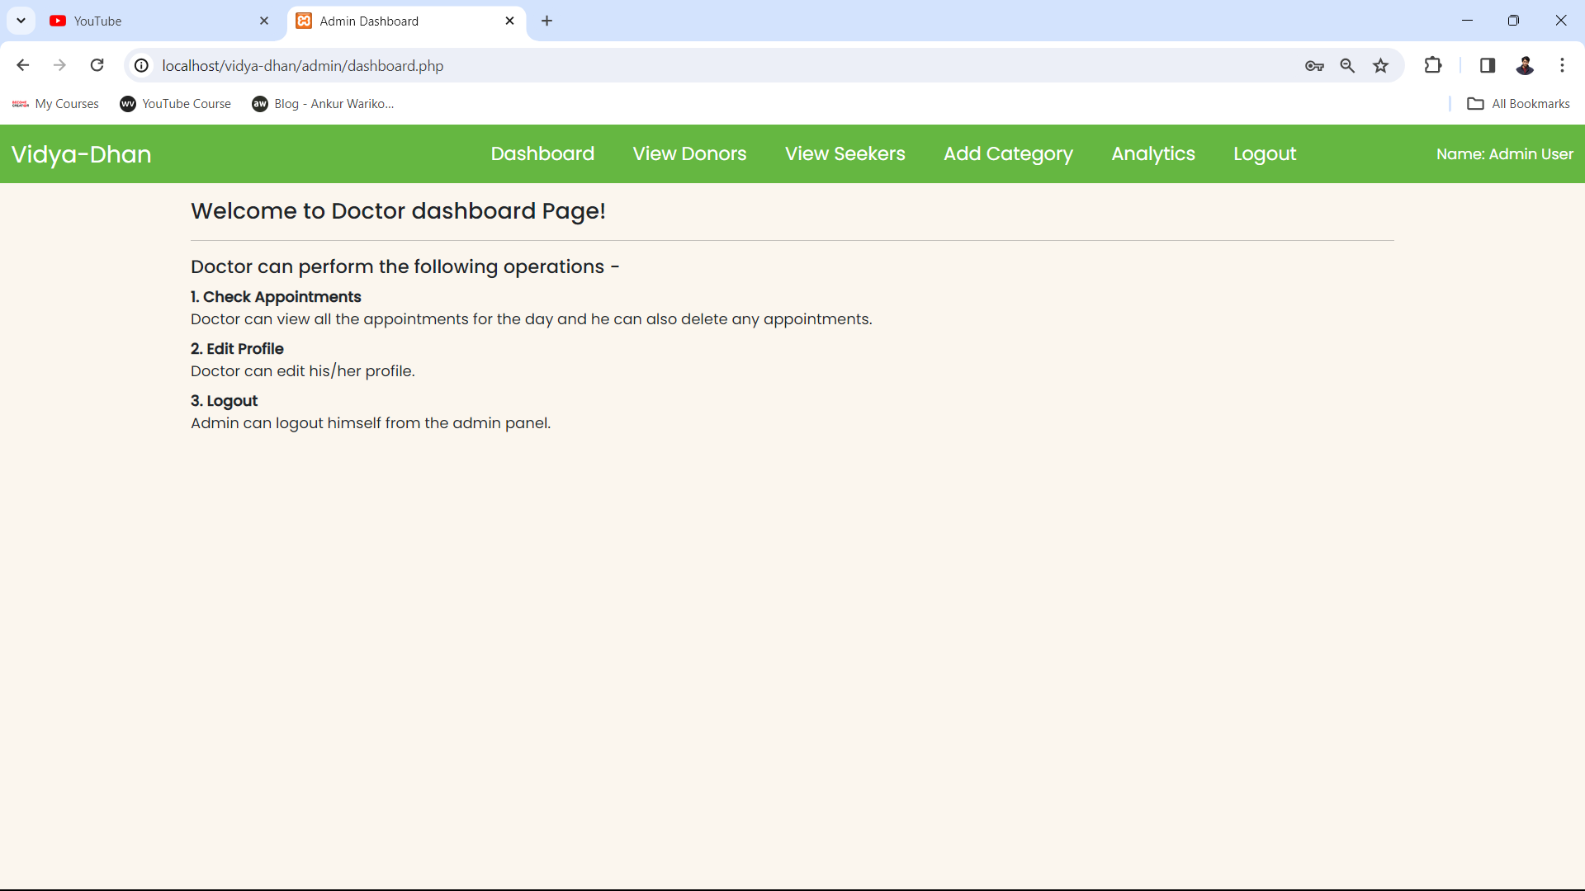

View Donor Page
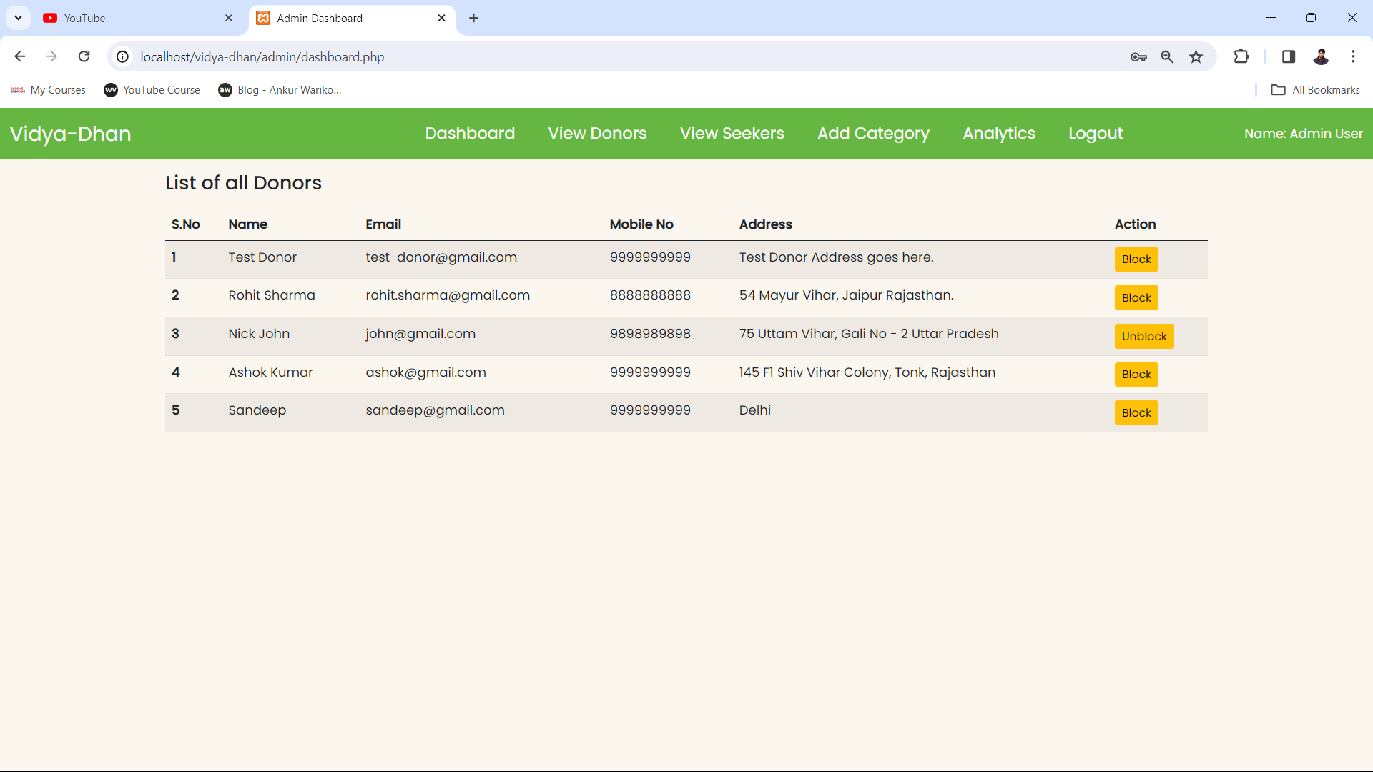
Analytics Page
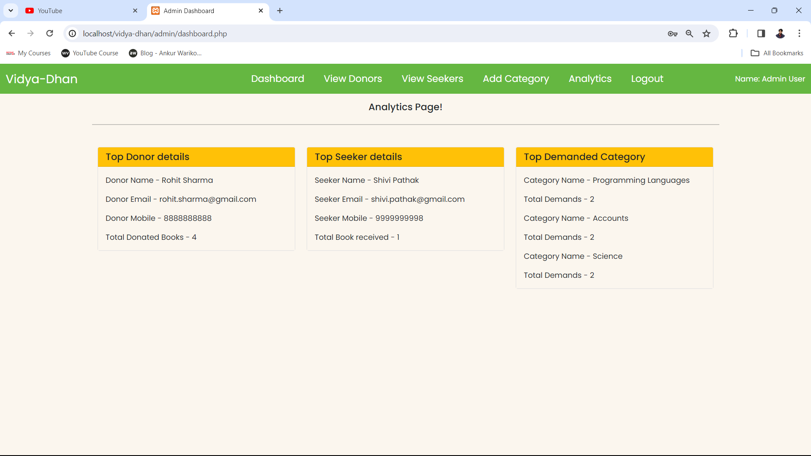

Donate book Page
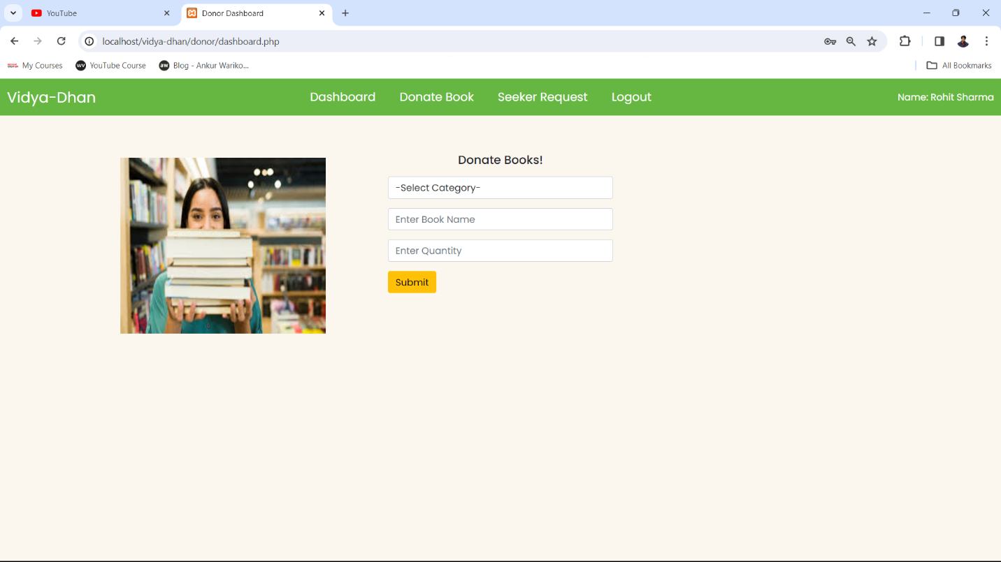
Seeker’s Dashboard
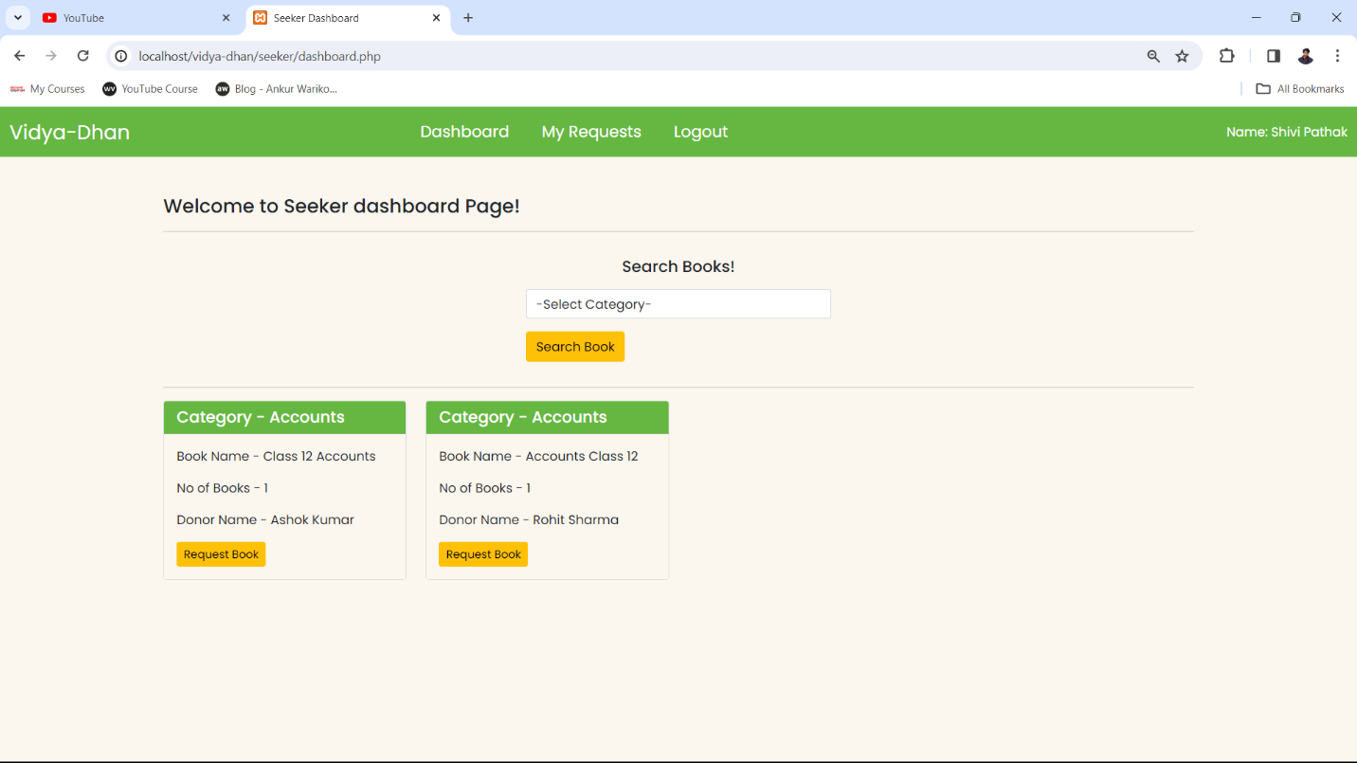

My requests Page
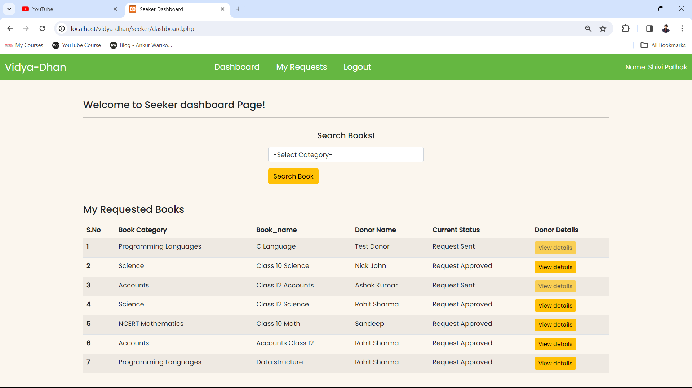
Summary and Conclusion
With the theoretical inclination of our syllabus, it becomes very essential to take the utmost advantage of any opportunity of gaining practical experience that comes along. The building blocks of this Major Project “Book Donation Management System” was one of these opportunities. It gave us the requisite practical knowledge to supplement already taught theoretical concepts thus making us more competent as a computer engineer. The project from a personal point of view also helped us in understanding many aspects.
The project also provided us the opportunity of interacting with our teacher and to gain from their best experience.

Thank you

Password
donors
Manage
Admins
status
address
mobile
mobile

Manage
status
mobile
Donate
Seekers
Donated_books
password
id
address
email
name
has
requests
status
Categories
Book_name
Book_requested
id
Cat_name
Cat_id
Book_cat
Donor_id
Seeker_id
Some Screenshots of the project
Home Page

Admin Login Page
Donor register page

Admin Dashboard Page

View Donor Page
Analytics Page

Donate book Page
Seeker’s Dashboard

My requests Page
Summary and Conclusion
With the theoretical inclination of our syllabus, it becomes very essential to take the utmost advantage of any opportunity of gaining practical experience that comes along. The building blocks of this Major Project “Book Donation Management System” was one of these opportunities. It gave us the requisite practical knowledge to supplement already taught theoretical concepts thus making us more competent as a computer engineer. The project from a personal point of view also helped us in understanding many aspects.
The project also provided us the opportunity of interacting with our teacher and to gain from their best experience.

Thank you

